Homework 2 – 2D-DCT
314552046莊明憲
SPEC
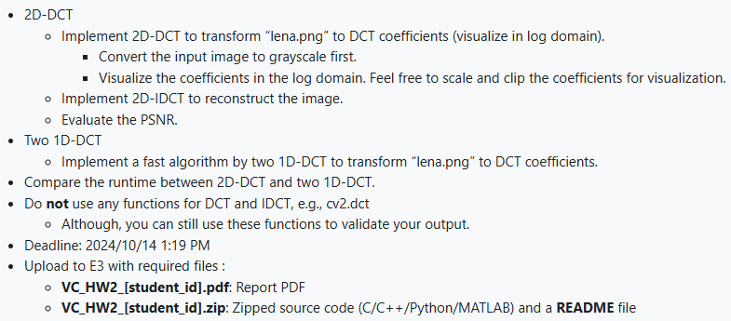
Formula
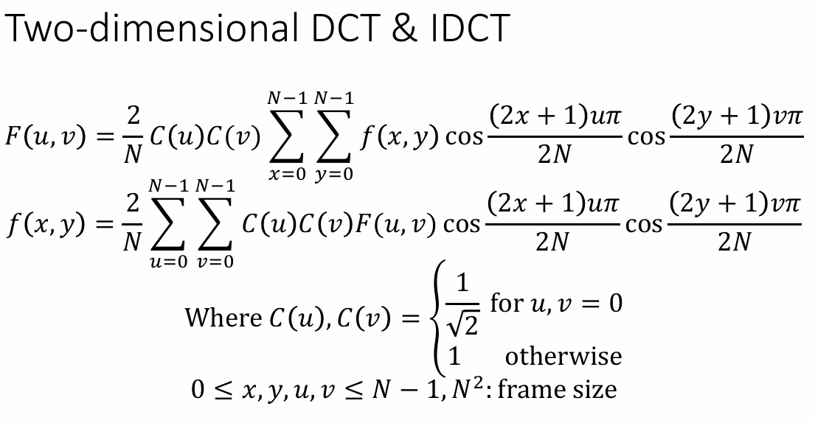
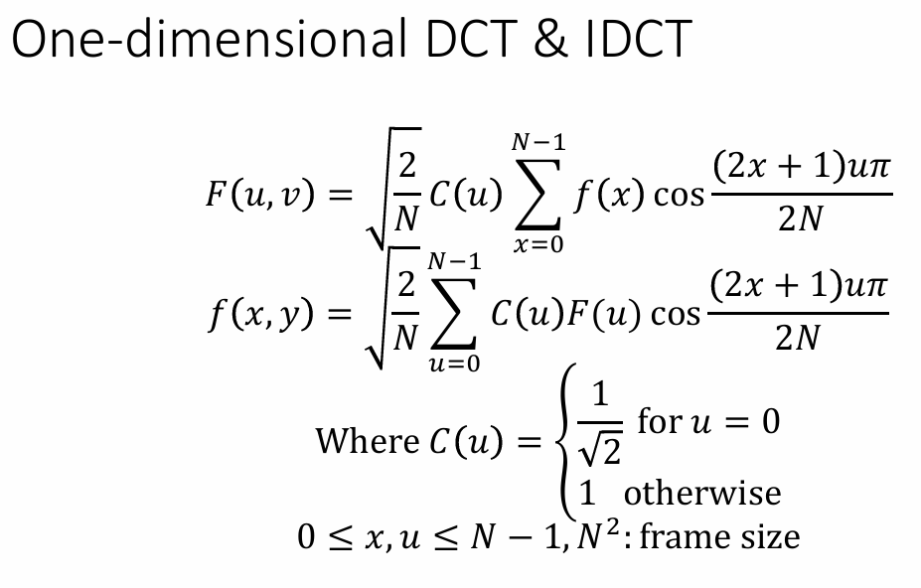

Code Explanation
- 2D-DCT & Mathematical Helper function
The helper function C(k) defines the scaling factor used in the DCT computation.
The function dct_2d(f_xy) computes the 2D-DCT of the input image.
It first initializes the output array and generates index grids x and y.
Two nested loops iterate over each frequency pair (u, v).
Inside the loops, cosine terms for both directions are precomputed, and np.sum() is used to replace the double summation in the original formula for faster computation. The results are stored in F_uv, which holds the final DCT coefficients. 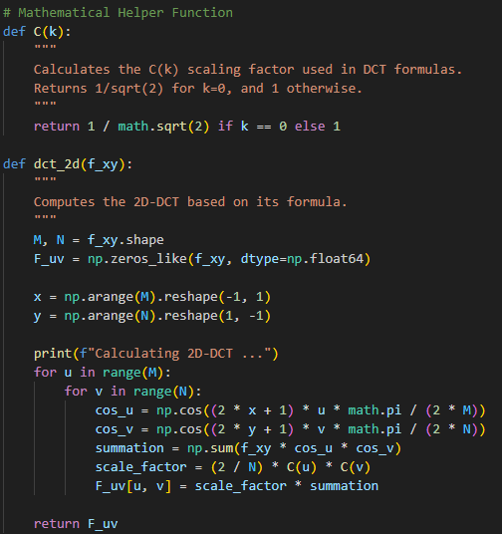
- 2D-IDCT
This function idct_2d(F_uv) performs the inverse 2D-DCT operation.
It first initializes an empty array for the reconstructed image and prepares index vectors u and v. To simplify the scaling computation, two vectors c_u and c_v are defined and combined using np.outer() to form a 2D scaling matrix. During the nested loops over (x, y), cosine terms are generated similarly to the forward DCT. Inside each loop, np.sum() is used to sum over the entire matrix product scale_matrix * F_uv * cos_u * cos_v, effectively replacing the double summation in the formula with a single optimized numpy operation. The resulting value is stored in f_xy[x, y]. 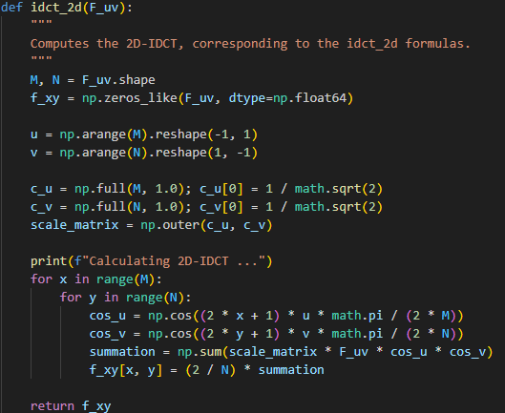
- Two 1D-DCT
This function implements 2D-DCT by calling 1D-DCT twice. It first uses np.cos to build a cosine vector for each frequency term, allowing reuse of these precomputed values when computing the dot product with the input signal. The expression f_x @ cos_terms efficiently replaces manual summations and accelerates the transformation. The scaling factor adjusts the coefficient magnitude based on DCT normalization. Finally, np.apply_along_axis applies dct_1d along rows and then columns, completing the 2D transform and returning the coefficient matrix F_uv. 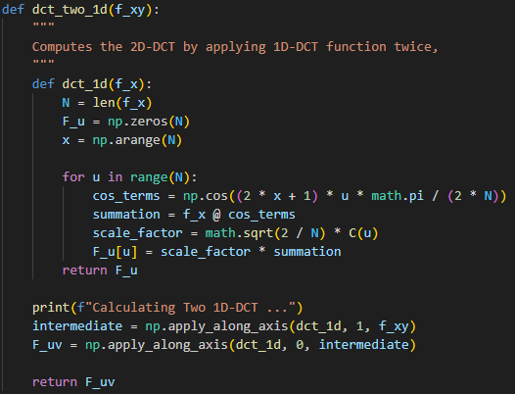
- Two 1D-IDCT
This function performs 2D-IDCT by applying 1D-IDCT twice, reversing the 2D-DCT process. Inside idct_1d, a coefficient vector c_u is first initialized, with the DC term scaled by 1/sqrt(2)​ to match the normalization rule. Then np.cos builds cosine basis vectors for each spatial position, allowing reuse during the dot product computation c_u * F_u @ cos_terms, which efficiently replaces nested loops. The scaling factor sqrt(2/N) restores the original signal amplitude. Finally, np.apply_along_axis applies idct_1d along both axes—first rows, then columns—to reconstruct the spatial-domain image matrix f_xy from the frequency-domain coefficients. 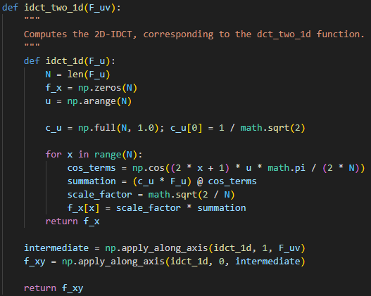
- Get_visual_dct_image
This function adjusts the DCT coefficients for better visualization. I first apply a logarithmic scale to compress the large dynamic range, making both low- and high-frequency components more visible. Then, I clip the coefficient values between the 1st and 99th percentiles to remove extreme outliers that would otherwise dominate the contrast. Finally, I normalize the result to 8-bit intensity values for display, producing a visually balanced grayscale representation of the DCT spectrum. 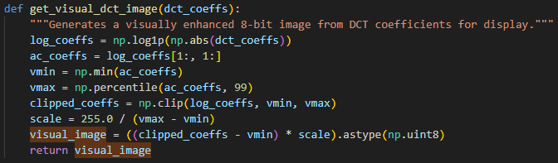
- Main block
This section compares the performance of three different implementations. I measured the runtime for the standard 2D-DCT, the optimized version using two sequential 1D-DCTs, and OpenCV’s built-in DCT/IDCT functions for validation. Each method also reconstructs the image using its corresponding IDCT and calculates PSNR to evaluate reconstruction quality. This comparison highlights the efficiency advantage of the two 1D-DCT approach while confirming correctness through the OpenCV results. 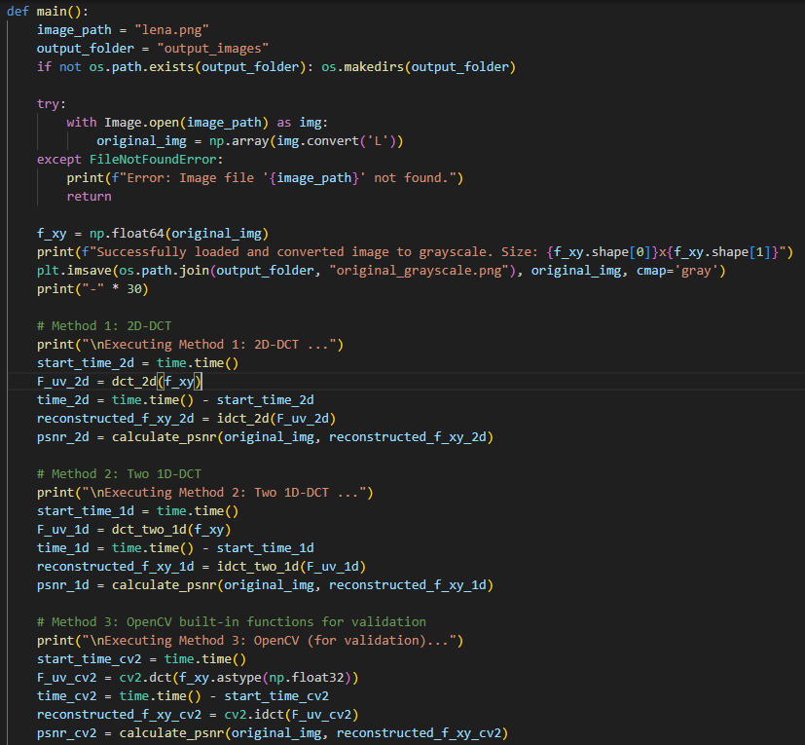

Result
 | DCT Coefficient | Reconstructed Image
2D-DCT | 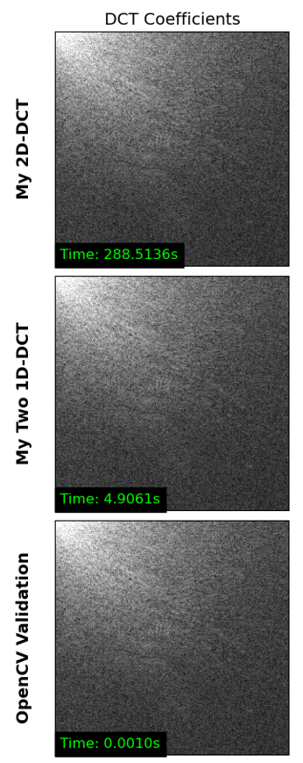 | 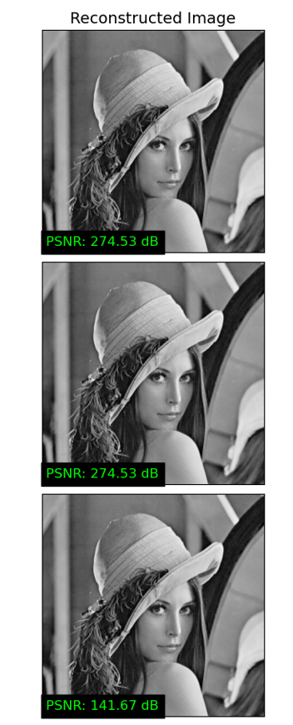
Two
1D-DCT
OpenCV-DCT
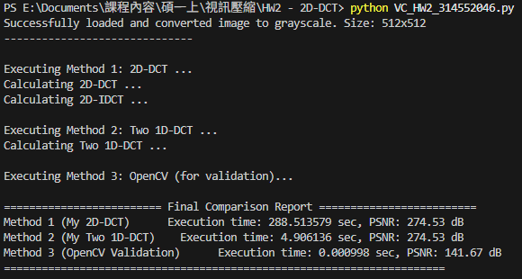
Comparison & Analysis
- The result shows that the Two 1D-DCT implementation is dramatically faster than the direct 2D-DCT, reducing execution time from about 288 seconds to around 5 seconds — roughly 60× faster. This confirms that decomposing 2D-DCT into two sequential 1D operations is a highly effective optimization.
- The PSNR values of both self-implemented methods are identical (274.53 dB), proving their correctness and numerical consistency.
- The OpenCV implementation runs almost instantly but produces a significantly lower PSNR (141.67 dB). This suggests that OpenCV’s internal DCT likely uses different scaling or approximation strategies that trade accuracy for speed, making it less ideal for strict reconstruction but excellent for real-time applications.

